

**Nuclear Instrumentation and Measurement**

**0407204, Fall 2024-25**

**Final Exam**

|  |  |
| --- | --- |
| **Instructor:** | **Dr. Muhammad Zubair** |
| **CRN:** | **11582** |
| **Section:** | **11** |
| **Date:** | **Dec. 9, 2024, 11:00 am – 1:00 pm** |
| **Place:** | **M10-101** |

|  |  |  |  |
| --- | --- | --- | --- |
| Student Name: | **Solution** | **ID:** |  |

**Grading**

|  |  |  |  |  |
| --- | --- | --- | --- | --- |
| **Q1** | **Q2** | **Q3** | **Q4** | **Total** |
| **11** | **11** | **11** | **12** | **45** |
|  |  |  |  |  |

**Answer all of the following questions:**

**Question #1 (6+5):**

A simple experiment was performed to study the gamma-ray attenuation properties of an absorber material. The geometrical setup is shown in the figure where the source is placed in the lead shield. Given the following:

**vacuum**

**vacuum**

* the source undergoes beta decay to an excited state of the daughter nucleus
* the daughter nucleus decays by emitting a gamma ray with energy 511 KeV

**Gamma detector**

* the absorber thickness is 2 cm (precisely measured)
* the detector reads 2000 counts in 20 minutes with the absorber present
* the detector reads 2500 counts in 10 minutes without the absorber present
* the background counts are negligible

**Answer the following:**

1. Calculate the linear attenuation coefficient of the absorber material
2. What is the probability per unit distance that the gamma rays do not interact in the absorber material?
3. During the 20-minute measurement, if 10 gamma rays scatter in the absorber and are counted in the detector with the 2000 counts, what is the value of the build-up factor?

**Solution**

i. Counts/minute with absorber = 100 counts/minute

Counts/minute without absorber = 250 counts/minute

ii. Probability of no interaction = 1 - µ = 1 - 0.45814 = 0.54816 cm-1

iii. Build-up factor = B= Total/Penetrated = 2010/2000 = 1.005

**b.** Cs-137 beta decays to an excited state of Ba-137, which eventually decays to the ground state of Ba-137 by emitting a 0.662 MeV gamma-ray. If the following experimental setup is used to detect the gamma rays, determine the energy deposited in the detector for the three different cases shown in the figure. Clearly state any assumptions you make.

NaI Detector

Lead Shield

90O

45O

**Solution:**

1) Energy deposited= full energy deposition= 0.662 MeV

2)

Energy deposited=0.662 - 0.20613 = 0.45587 MeV

3)

Energy deposited=0.2884 MeV

**Question #2 (3+4+4):**

**a.** Why does the pulse height from a Geiger tube continue to increase with applied voltage even after a full Geiger discharge is obtained?

It is the space charge buildup around the anode wire that limits the size of the GM pulse. This limit is achieved later (higher multiplication) with increased electric fields in the detector. Since increased applied voltage implies increased electric field, the pulse height will be larger with higher applied voltages.

**b.** Explain two advantages and two disadvantages of the following detectors:

i) High Purity Ge detectors

ii) Gas-filled Geiger-Muller counters



**c)** A beam of alpha particles produced a current of 10–14 A in a parallel-plate ionization chamber filled with helium for 6 s. If the first ionization potential for helium is 24.5 eV and the average energy to create an ion pair in helium is 42.7 eV,

1. Calculate the charge produced
2. Calculate the energy deposited in the chamber in Joules

q = 10-14 * 6 = 6x10-14 C

number of ion pairs = 6x10-14 / 1.6x10-19 = 3.75x105

1. W-value for alpha particles in air = 42.7 eV/ion pair

Total energy = 3.75x105 x 42.7= 16.0125 x 106 eV = 16.0125 MeV = 2.56552x10-12 J

**Question #3 (6+5):**

**a.** One of the commonly reactions in detecting slow neutrons is the following:

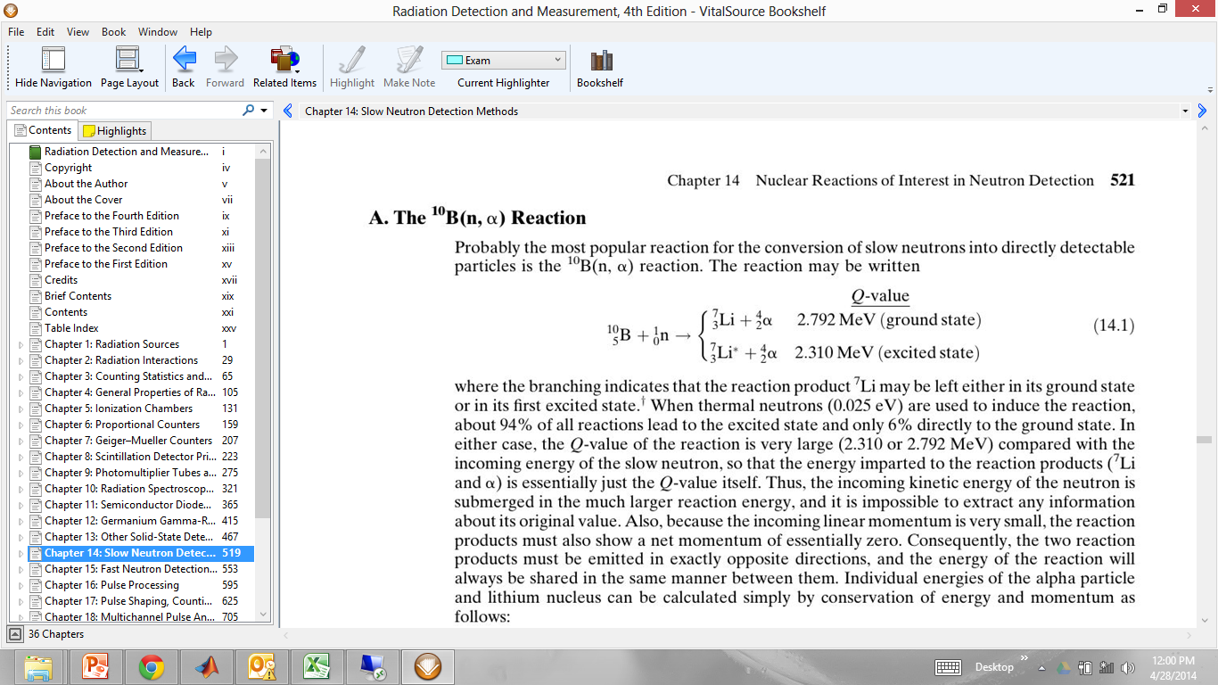

94%

6%

When using an intermediate size BF3 proportional tube to detect slow neutrons, the following spectrum may result:

1. Thoroughly explain all the features and peaks in this spectrum.
2. What is the “Wall effect” and how does it occur?

**Solution:**

For the 2.31 MeV reaction, the energies are as follows:

* ELi= 0.84 MeV
* Eα= 1.47 MeV

The area under the 2.79 MeV peak corresponds to ~6% and the remaining to ~94%

For intermediate and small detectors (size less than the range of the particles), the “Wall Effect” is observed and partial energy deposition occurs.



**b.** A cylindrical proportional tube has an anode wire radius of 0.0025 cm and a cathode radius of 1.8 cm. It is operated with an applied voltage of 2200 V.

1. Calculate the electric field in the tube at radii 0.00025 and 0.00155 m.
2. ****If the minimum electric field to initiate gas multiplication is 1.0 MV/m, what is the maximum radius for gas multiplication to occur?

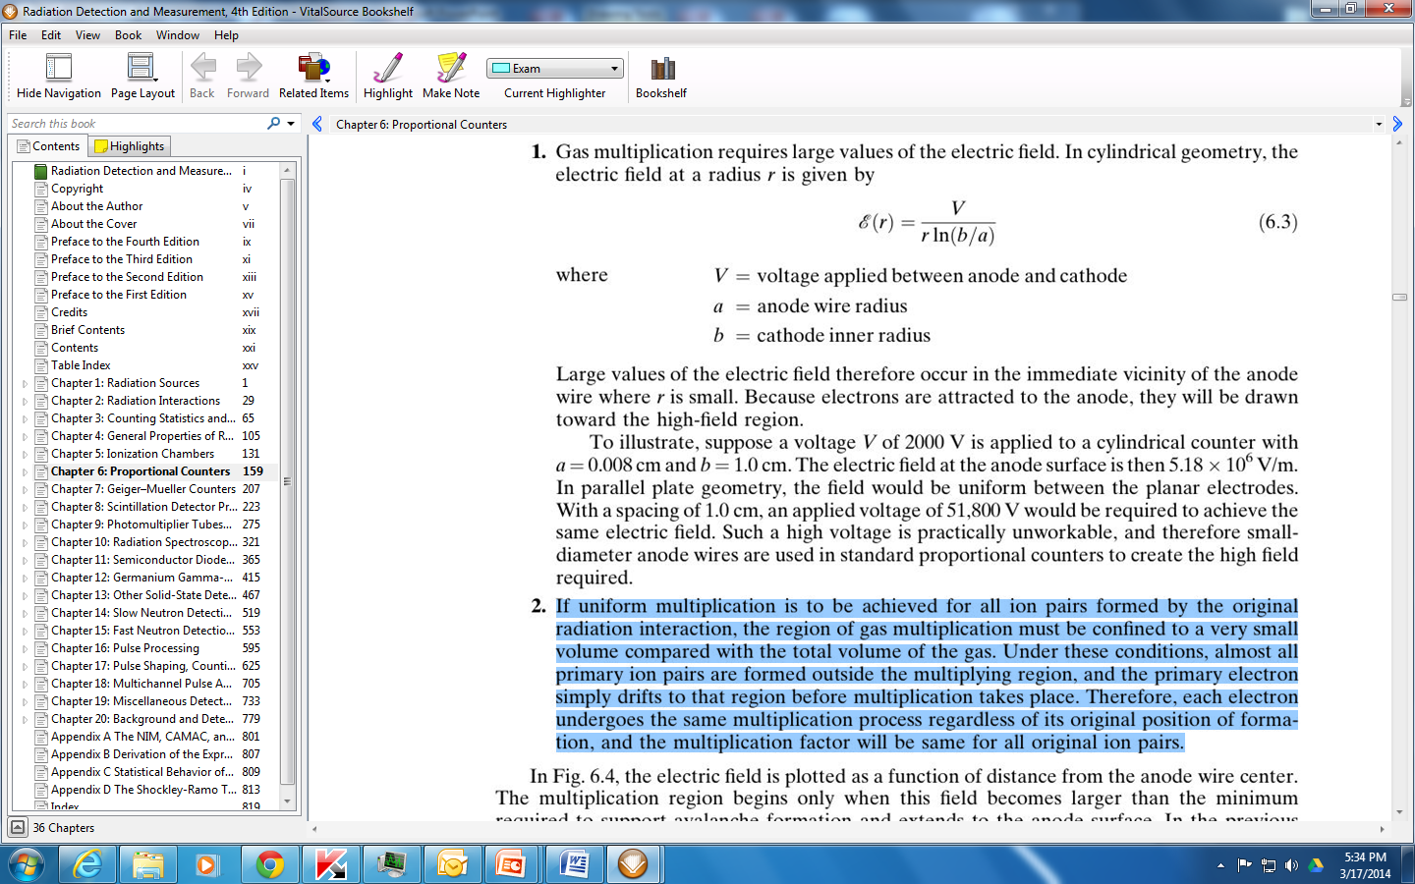**Solution:**

|  |  |  |
| --- | --- | --- |
| **a** | 0.0025 | cm |
| **b** | 1.8 | cm |
| **V** | 2200 | V |
|  |  |  |
| **r (m)** | **E (MV/m)** |  |
| 0.00025 | 1.337538 |  |
| 0.00035 | 0.955384 |  |
| 0.00045 | 0.743077 |  |
| 0.00055 | 0.607972 |  |
| 0.00065 | 0.514438 |  |
| 0.00075 | 0.445846 |  |
| 0.00085 | 0.393394 |  |
| 0.00095 | 0.351984 |  |
| 0.00105 | 0.318461 |  |
| 0.00115 | 0.290769 |  |
| 0.00125 | 0.267508 |  |
| 0.00135 | 0.247692 |  |
| 0.00145 | 0.23061 |  |
| 0.00155 | 0.215732 |  |
| 0.00165 | 0.202657 |  |
| 0.00175 | 0.191077 |  |
| 0.00185 | 0.180748 |  |
| 0.00195 | 0.171479 |  |
| 0.00205 | 0.163114 |  |
| 0.00215 | 0.155528 |  |
| 0.00225 | 0.148615 |  |
| 0.00235 | 0.142291 |  |
| 0.00245 | 0.136483 |  |
| 0.00255 | 0.131131 |  |
| 0.00265 | 0.126183 |  |
| 0.00275 | 0.121594 |  |
| 0.00285 | 0.117328 |  |
| 0.00295 | 0.113351 |  |
| 0.00305 | 0.109634 |  |

Substituting in the equation above, 1 MV/m occurs at approximately r= 0.000335 m

**Question #4 (8+4):**

**a.** The figure below shows a typical arrangement of a photomultiplier tube. Explain the function of:

1) Photocathode

2) Glass envelope

3) Dynodes

4) Anode

1) Photocathode

Convert as many of the incident light photons as possible into low-energy electrons

2) Glass envelope

Serves as a pressure boundary to sustain vacuum conditions inside the tube that are required so that low-energy electrons can be accelerated efficiently by internal electric fields

3) Dynodes

Serves as an efficient collection geometry for the photoelectrons and serving as a near-ideal amplifier to increase their number significantly.

4) Anode

A collection of all the amplified electrons 

**b.** A beam of collimated neutrons of energy 4 eV is incident on a BF3 detector. Given the following:

Neutron source

BF3 Detector

1. BF3  detector length = 20 cm
2. BF3  detector radius = 1.5 cm
3. Boron-10 atoms density= 1.7x1019 cm-3
4. absorption cross-section of 4 eV neutrons in

B-10 is approximately 310 barns

Calculate the efficiency of this detector for these neutrons.

**Useful Data:**

1 amu=1.6605x10-27 kg,

1 amu ≡ 931.48 MeV,

1 eV = 1.6022 × 10-19 J ,

me = 0.0005486 amu

Avogadro’s number= 6.022x 1023

1 barn = 10-24 cm2

Density of air = 0.001225 g/cm3

W-value for alpha particles in air = 35.1 eV/ion pair







